**Part A: Algorithms**

|  |  |
| --- | --- |
| **1.**  **2.**  **3.**  **4.** | What is the function of the following pseudo-code? |

**Part B: The Growth of Functions**

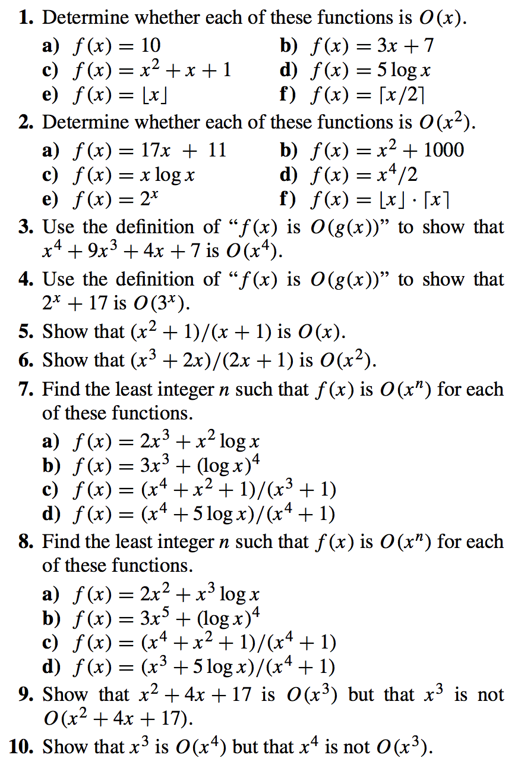

|  |  |
| --- | --- |
| **11.**  **12.**  **13.** |  |